“Ann’s Creative Corner”

Project Number 9: Hop Scotch
- Bring some sidewalk chalk outdoors
- Draw various types of Hop Scotch patterns; can be simple two by two or one and then two etc. Draw numbers, shapes or picture on each Jumping area.
- Can be squares, circles, triangles or whatever you choose.
- For older children, talk of shapes and colours.
- Get a small soft but weighted object such as a Bean Bag.
- Throw the item (bean bag) onto the number. Hop to get it. Can hope on one Foot, two feet or whatever the level is for the Toddler or Child. Be flexible and it is okay to hop in or out of the lines.
- Pick up the “Bean Bag” if you can and hop to the end.
- Be flexible and have fun.
- Indoors, a Foam Hop Scotch can be used or hook together your own interlocking Squares if you have some.
- Carpet Hop Scotch may be purchase as well.

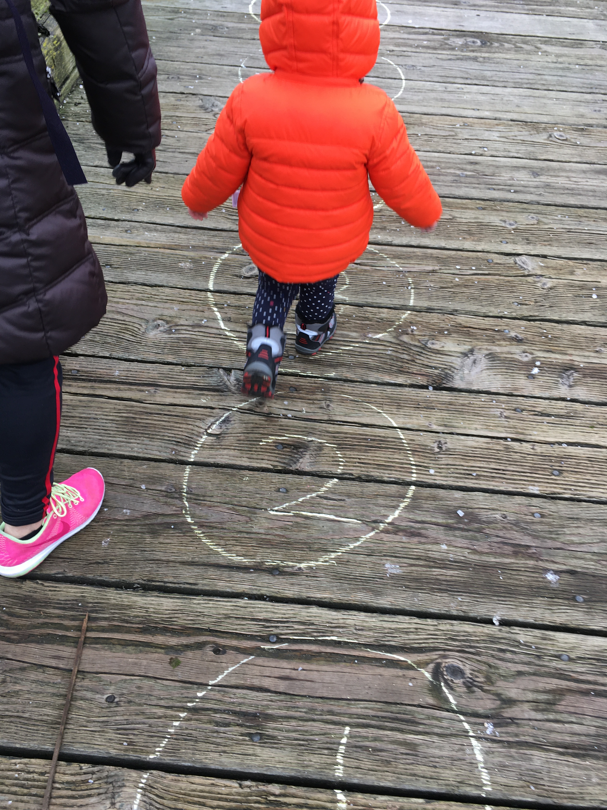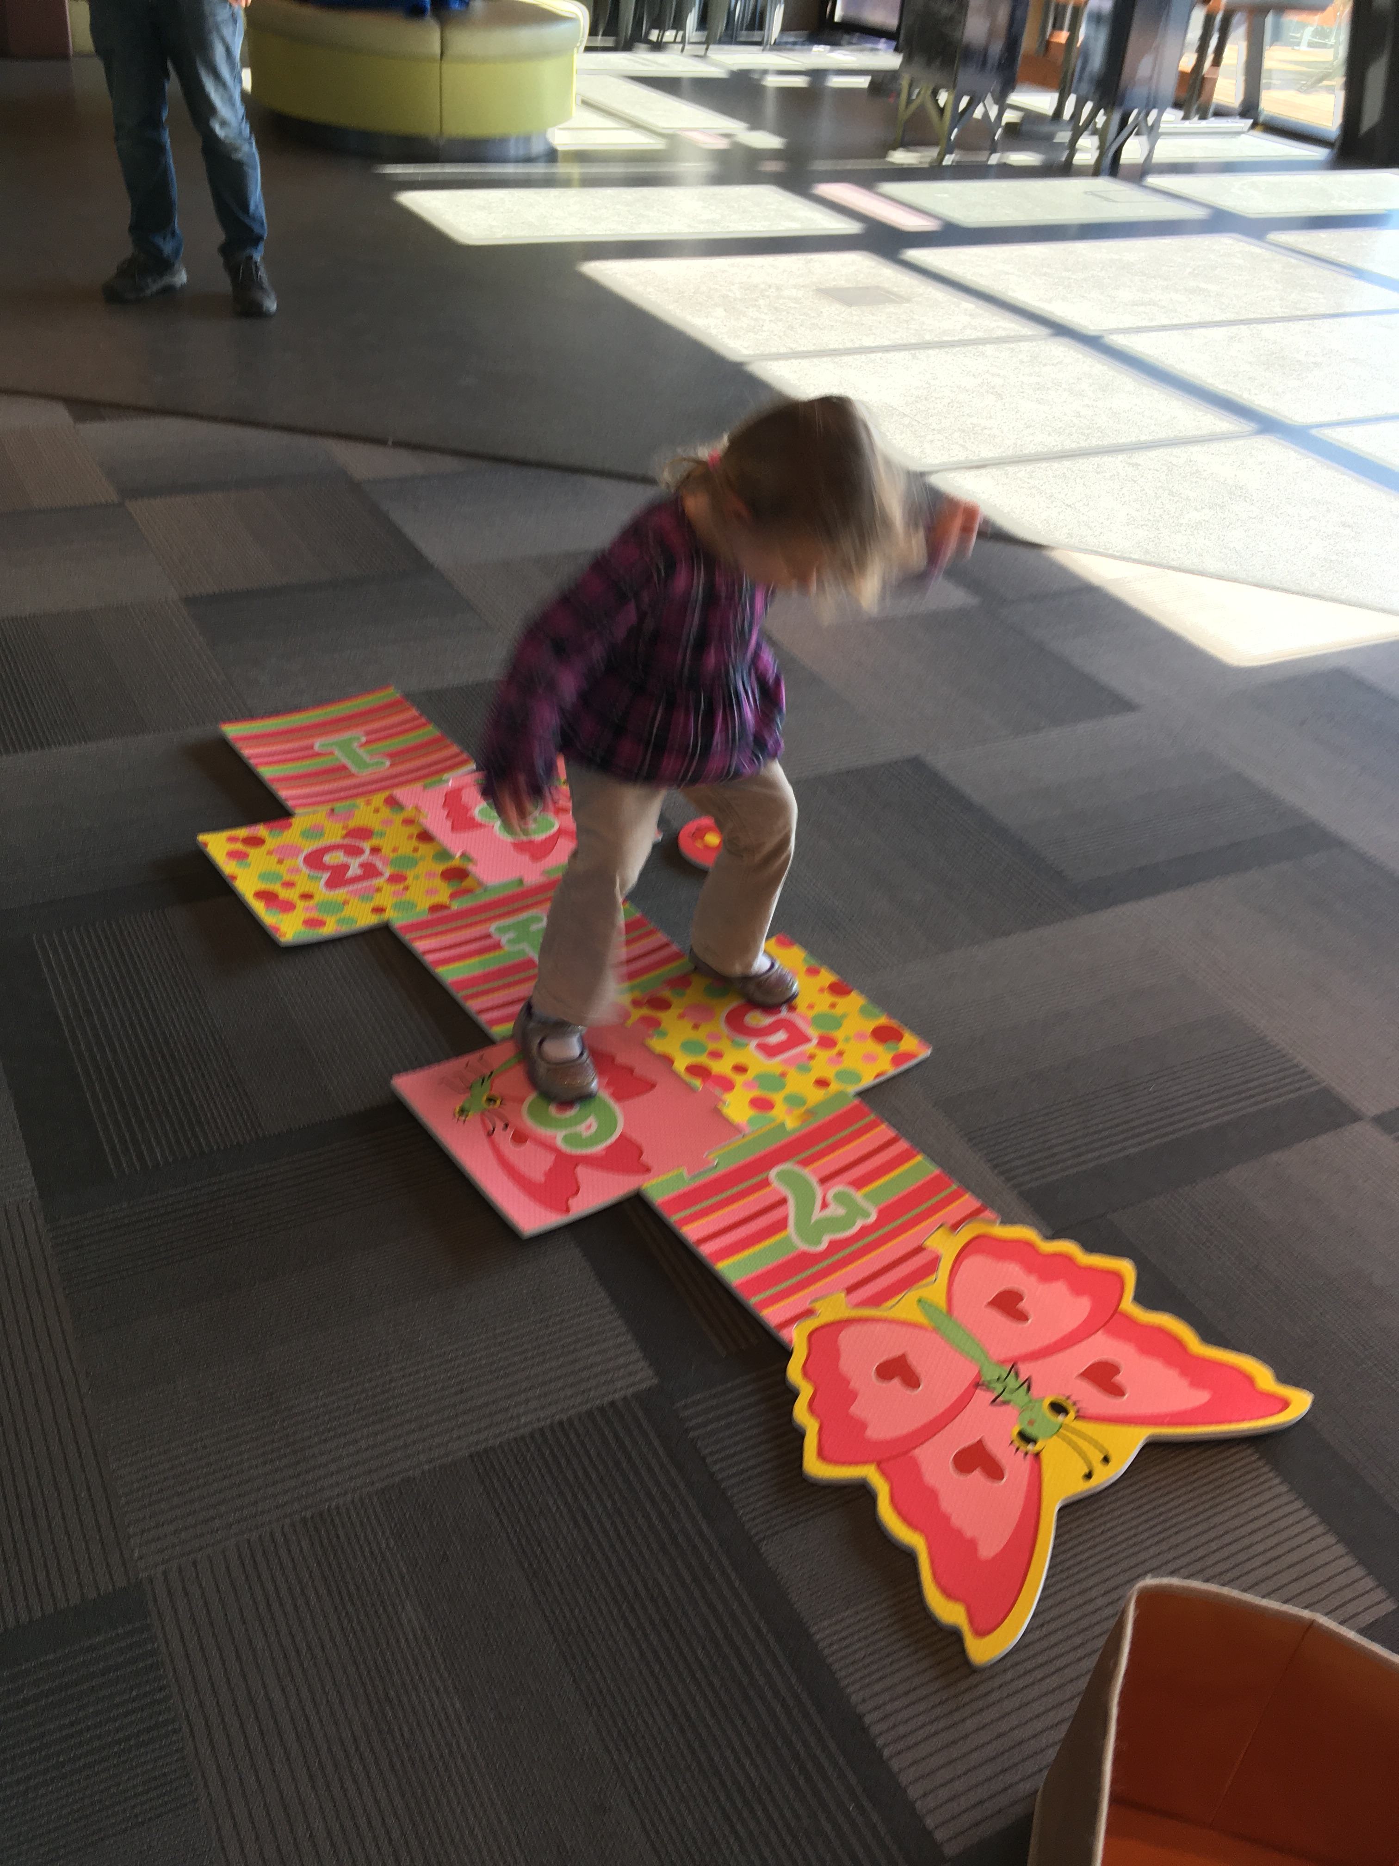
Enjoy Hopping!

