April 03, 2020

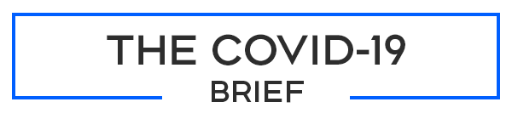

CORONAVIRUS UPDATE

Your resource for cutting through the fear and misinformation. Every Monday, Wednesday and Friday, check your email for trusted CTV News reporting and analysis to help differentiate between fact and fiction.
The outbreak by the numbers (as of 9:30 a.m. Friday, April 3, 2020):
- Globally: 54,369 dead | 1,033,478 infected | 218,864 recovered
- Canada: 138 dead | 11,283 cases | 1,971 recovered | 15 presumptive
- British Columbia: 1,121 cases, 31 deaths, 641 recovered
- Alberta: 968 cases, 13 deaths, 174 recovered
- Saskatchewan: 206 cases, 3 deaths, 36 recovered
- Manitoba: 167 cases, 1 death, 11 recovered
- Ontario: 2,793 cases, 53 deaths, 831 recovered
- Quebec: 5,518 cases, 36 deaths, 224 recovered
- New Brunswick: 91 cases, 22 recovered
- Nova Scotia: 193 cases, 16 recovered
- Prince Edward Island: 22 cases, 3 recovered
- Newfoundland and Labrador: 183 cases, 1 death, 10 recovered
- Yukon: 6 cases, 3 recovered
- Northwest Territories: 2 cases
- Trenton (CFB quarantine): 13 cases

