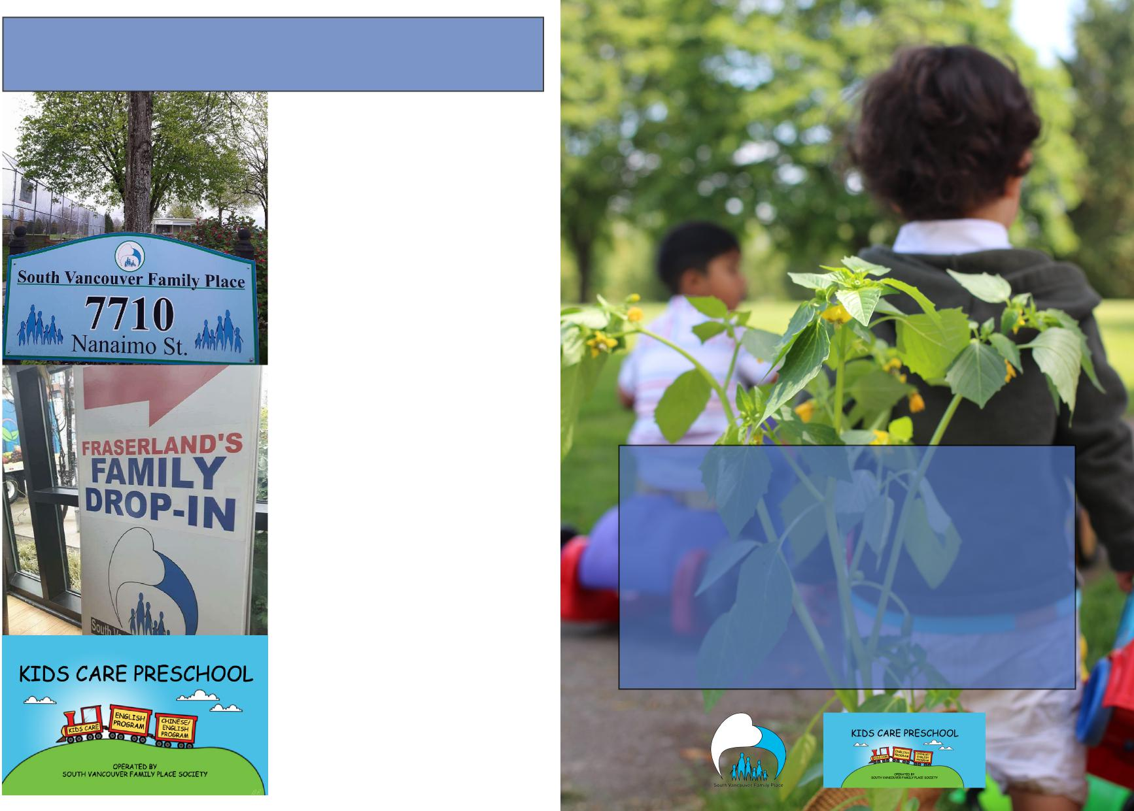

**South Vancouver**

**Family Place**

**Society**

**Annual General**

**Meeting**

June 28th, 2018

**Since 1976**

**Contacts**

**South Vancouver**

**Family Place**

7710 Nanaimo Street Vancouver, BC V5P 4Y2

SVFP Tel. (604) 325 5213 [www.svfp.org](http://www.svfp.org)

**Fraserlands Family**

**Place**

8683 Kerr Street Vancou­ver, BC.

SVFP Tel. (604) 325 5213 [www.svfp.org](http://www.svfp.org)

**Kids Care Preschool**

7715 Muirfield Drive

Kids Care Tel. (604) 325 2222

[www.kidscarepreschool.org](http://www.kidscarepreschool.org)

**19**

**Paula Fitzpatrick Laura Levera**

**Andrea Pohler Wendy Ma**

**Lal Dhillon Lindsey Bogunovic**

**Carrie Cassidy Jannie Szeto**

Welcome to the Annual General Meeting 2018.

It hardly seems as though a year has passed but summer is almost upon us.

South Vancouver Family Place is a place of connection, where families and caregivers can come together to build support within the community. Improved access, program expansion, and secure and stable funding were all major goals of our strategic plan, and it is a testament to our incredible staff, executive director, and our legion of amazing volunteers, that I can bring to you Whats has been accomplished in the past year.

The drop in continues to be the heartbeat of the organization, and we have seen increased atten­dance in all programs both here and at the Fraserlands. It is from this strong foundation we have expanded into new exciting programing.

With a focus on food and how food brings families together, Healthy Together, a pilot project running at SVFP and the Fraserlands has been a huge success. It has run for 28 weeks, bringing together people who are invested in making healthy choices for themselves and their families. We have also received funding from Vancouver Coastal Health to support food programming for immigrant seniors. Both these programs align nicely with our partner, Growing Eden, an organi­zation committed to growing community through food security and a communal gardens.

Our relationship with funders is deepening, with both Wesgroup and Westminster Savings ex­panding their commitment to support the Fraserlands into the summer months, and an interest in exploring future opportunities. The City of Vancouver continues to be a vital contributor to our spaces, only last month putting in the brand new floors!

Other important relationships include the 5 Family Place partnerships, dedicated to increasing awareness for all family places within the city and their impact on the community.

Our preschool is full, and we have a successful kindergarten transition program for kids and caregivers running at Trudeau Elementary.

We have just finished our annual Scotiabank Charity Challenge 5Km Walk/Run. Last year we were able to raise over $10,000 and we will continue to make this one of our largest fundraising effort, with a huge team of participants dedicated to our cause.

As the Chairperson of the board, I sincerely thank everyone for all the hard work and love put into the Family Place. We could not do the work we do without the many members, volunteers, staff, funders, stakeholders, and community partners with whom we share a commitment to families. It is an honour to be of service alongside such dedicated individuals.

Sally Fitzpatrick **18**

**Table of Contents**

**Table of Content 1**

**Our Mission 2**

**Executive Director 3**

**Programs 5**

**Parent Education 6**

**Kids Care Preschool 7**

**Partnerships and Community Outreach....8-9**

**Finances 10-11**

**Volunteers 12**

**Donations 13**

**Comments and Memories 14-17**

**Board of Directors 18**

**Contact Information 19**

**1**

**Board of Directors**

**City of Vancouver Ministry of Children and Families and Development**

**Funders**

**Major Funders: Partners:**



**“Thank you to all of our Funders, Partners,
  
and donors for supporting SVFP this past
  
year in all its endeavors.
  
We couldnt have done it without you!”**

**17**

**BC Gaming**

**Westminster Savings Federal HRDC**

**(summer jobs)**

**CLICK**

**The Bridge Youth & Family Services**

**Our Mission**



**“South Vancouver Family Place’s**

**mission is to support families with**

**young children in building healthy**

**relationships and community**

**networks by providing services**

**and programs in a welcoming,**

**nuturing, and respectful**

**environment.”**

**2**

**Cascades Packaging** Pacific Immigrant **Resources Society**

**Executive Director**

It is hard to believe that another year has passed at South Vancouver Family Place. The Drop- In Programs and Preschool are always so busy that time seems to fly by. 2017/2018 was a great year with lots of new families and children accessing our different programs.

I would like to take this opportunity to thank our volunteer Board of Directors who help govern this great organization and also support and guide me throughout the year.

In 2017/2018, Family Place received a brand-new deck and finally a long overdue new floor. We ran many programs throughout the year including 2 – 14-week Healthy Together Programs and 2 Connecting Through Food Programs for our Grandparents. In addition, we offered a successful kindergarten transition program at Trudeau Elementary School, 3 Nobody’s perfect Parenting Programs, 1 Mother Goose Literacy Program and 3- 10-week Life as a Parent Group.

Fraserlands Drop-In Program continues to grow and welcomed 133 new families in 2017/2018. As the development continues, SVFP is working collaboratively with our partners at Wesgroup, Westminster Savings and the City of Vancouver to ensure resources and services for families will continue to be offered and hopefully, be expanded and enhanced. With bridge funding from Wesgroup, SVFP will be able to offer the Drop -In program throughout the summer as well.

Kidscare Preschool has had a very successful year with 70 children enrolled in both the English and Bilingual Programs. We continue to have a large waitlist for the program which is a testa­ment to the skilled and dedicated teachers at the Kidscare Preschool.

The Family Place Partnership in Vancouver continues to work collectively to advocate for fam­ilies with children 0-5 at the municipal and provincial level. We presented to the Mayor at City Council and are working with our local MLA’s and MCFD to ensure they understand the impact of our programming for families with children in Vancouver. The partnership was also honoured to present at the Early Years conference at UBC which enabled us to showcase what we do and the impact of our work.

At the heart of Family Place lies the dedicated and committed staff. They work tirelessly to ensure that families and children are welcomed, supported and given opportunities to grow and thrive. Syd Bosel, sadly, left SVFP in September after over 15 years of dedication but we are fortunate to still have her on contract with us. In June, after 17 years, Carol will be retiring and leaving Kid-scare Preschool. We are sad to see her go but wish her all the best in her adventures ahead.

We look forward to the year ahead and wish you all a happy and safe summer. Kimberley Berger

**3**

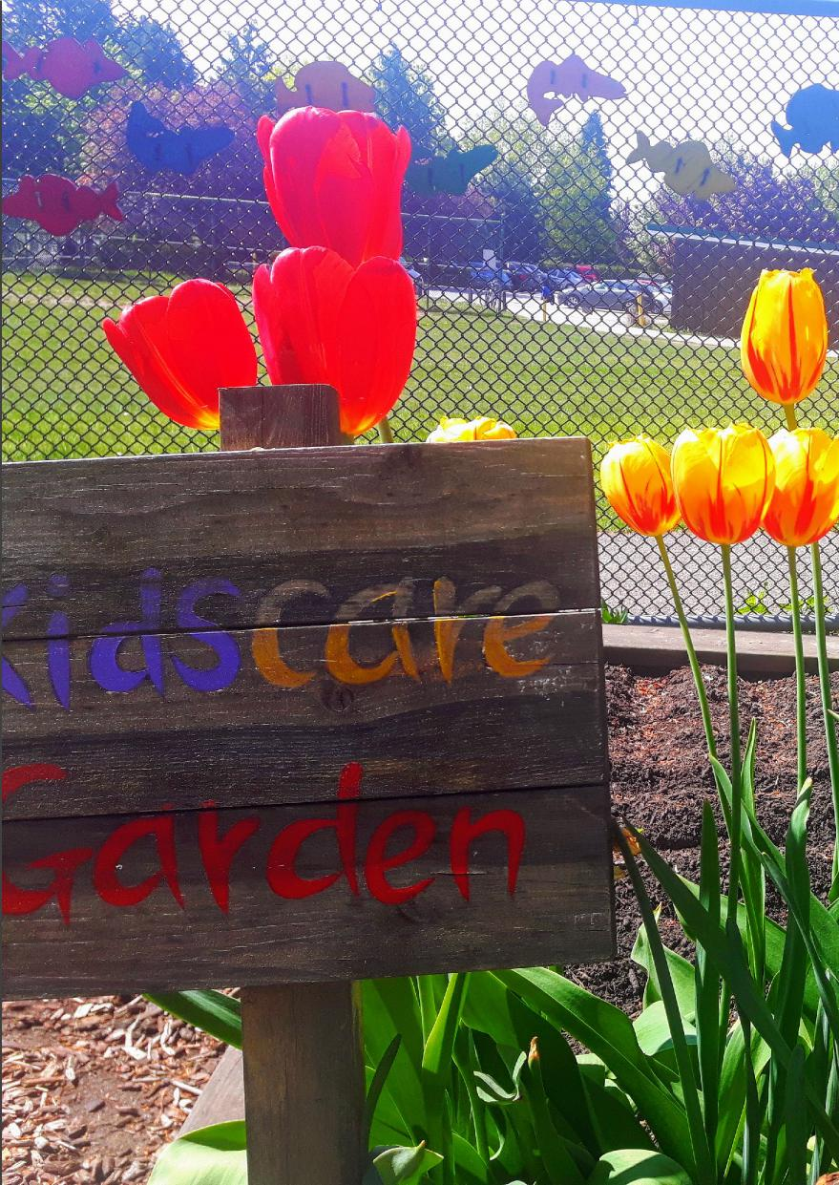

**16**

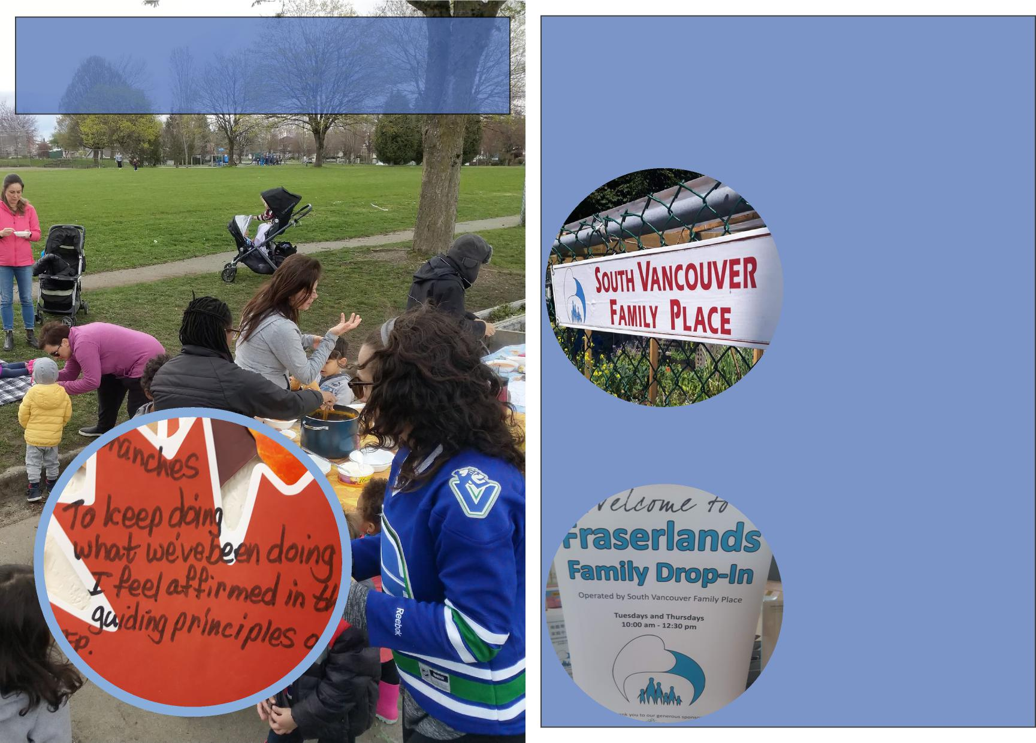

**Comments and Memories**

15

**Programs**

SVFP Family Drop-in

**TOTAL VISITS:**

**14,075**

Fraserlands Family Drop-in

**TOTAL VISITS:**

**4,542**

4

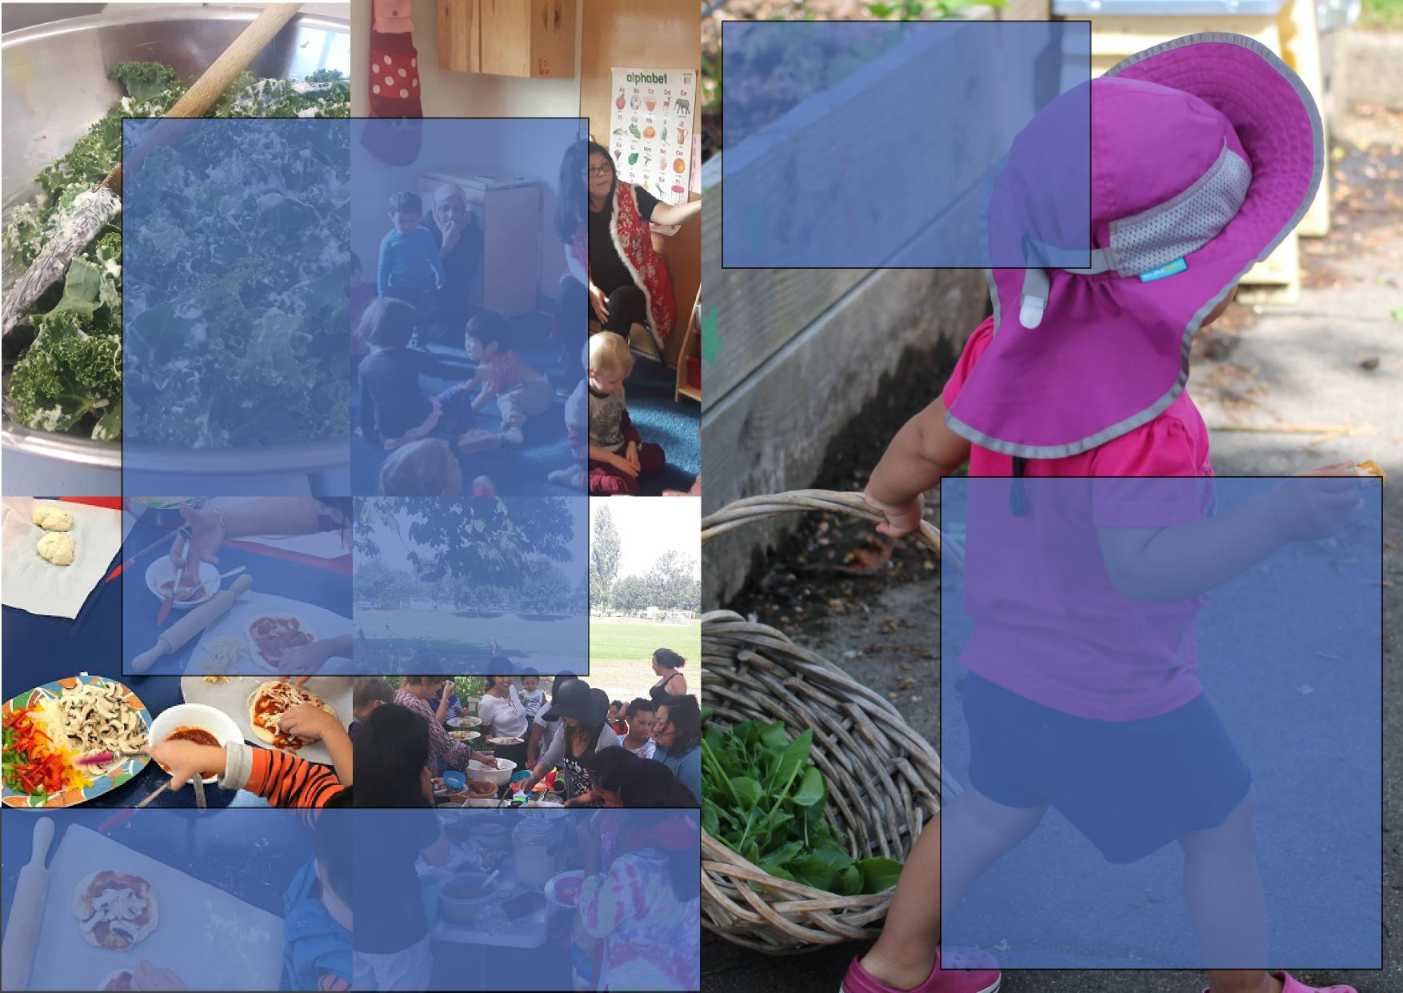

**HEALTHY**

**TOGETHER**

**TALKING ABOUT SEX, BODIES, RELATIONSHIPS TO YOUR CHILDREN**

**MOTHER GOOSE**

**CIRCLE OF SECURITY**

**PARENT EDUCATION**

**& LITERACY**

**GREENLIGHT TO**

**HT TO**

**RTEN**

**KINDERGARTEN**

**CONNECTING THROUGH FOOD BUILDING CULTURE THRU FOOD AND**

**Nobody’s**

**Perfect**

**NUTRITION**

**Life as a Parent**

**MONE**

**MONEY SKILLS WORKSHOP**

**TOTAL VISITS: 2220**

**5**

**14**

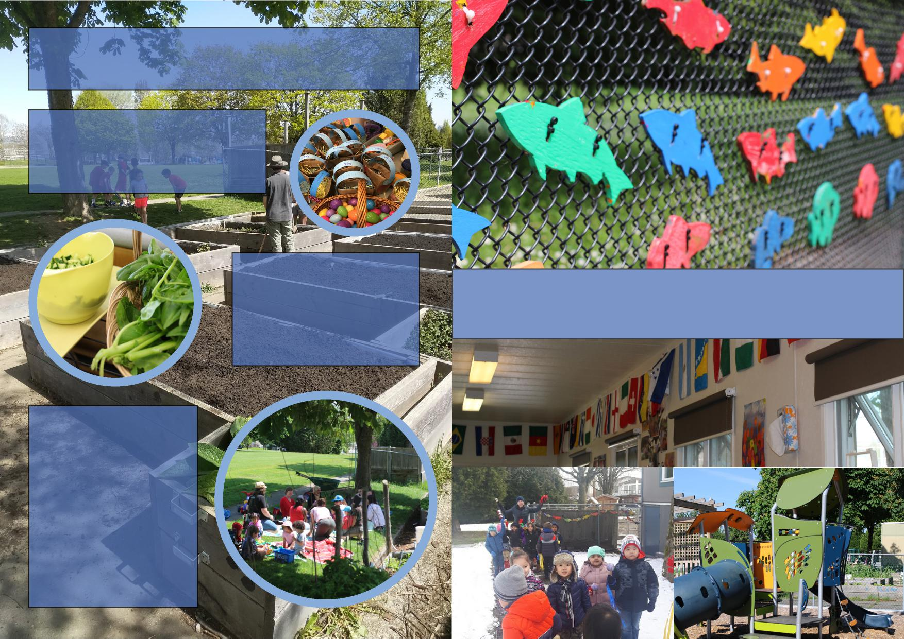

**Comments and Memories**

**Kids Care Preschool**

13

6

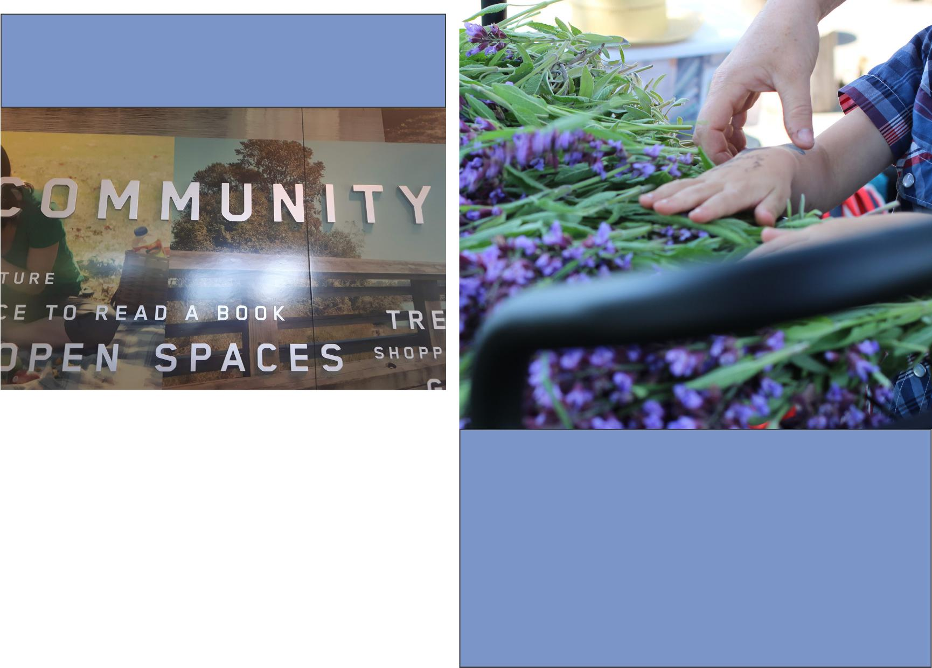

**Partnerships and**

**Community Outreach**

**EFL Properties Ltd/River District**

**Family Services of Greater Vancouver**

**Pacific Immigrant Resource Society**

**Growing Eden**

7

**5 Family Places Vancouver Public Library South Community Health Centre**

**South Vancouver Neighbourhood House Vancouver Coastal Health**

**In-Kind Donations**

**TOTAL VISITS:**

**$5,770**

12

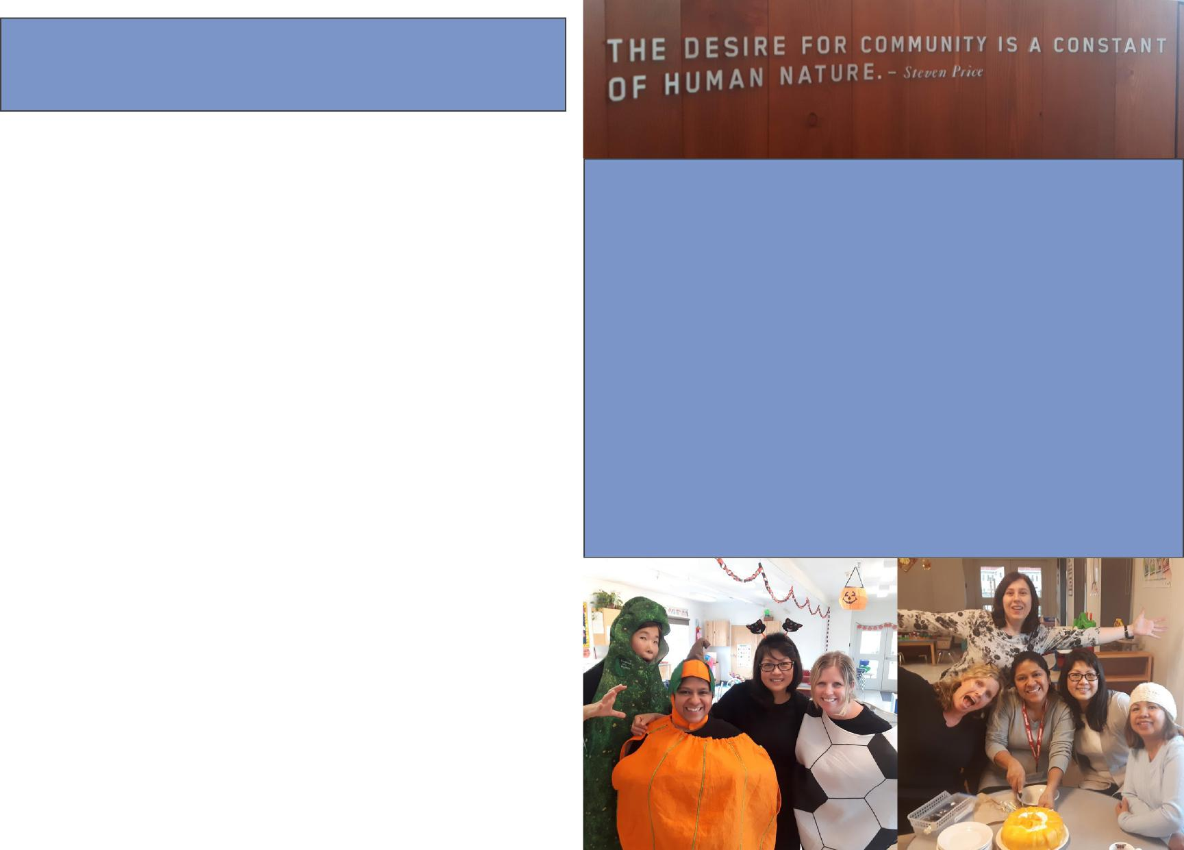

**Volunteers**

**$27,985**

11

8

**Volunteer contributions**

**TOTAL VISITS:**

**SVFP Staff Team 2017-2018:**

Kimberley A Berger Victoria Ragas Ingrid Rios Jen Luong Eva Joung Maiya Aliyeva Siu, Erika King Yin Carol Hardinge-Rooney

Michelle Wong Ann Asselstine Renee Parker Kenia Borges Manjit Garcha Chi Charchuk Fatima Nafis Sumitra Quiring

**Finances**

9 10